module RAM_16x8_ex2 (clk, CS, W, R, addr, i_data, o_data);

input clk;
input CS, W, R;
input [3:0] addr;
input [7:0] i_data;
output reg [7:0] o_data;

reg [7:0] Mem [0:15];

always @ (CS or W or R or posedge clk)
if(CS && W)
Mem[addr] <= i_data;
else if (CS && R)
o_data <= Mem[addr];

initial //initializing Mem
$readmemh ("memory.dat", Mem);

Initial //Displaying the data read from Mem
$monitor ($time, " %h", o_data);

endmodule
//memory.dat. The .dat file must be in the same directory as design and testbench. Otherwise you will need to specify the complete path.
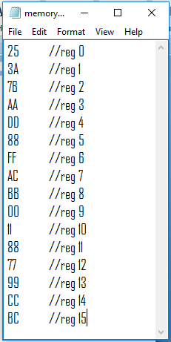

module RAM_16x8_ex2_testbench();

reg clk;
reg [3:0] address;
reg CE, write, read;
reg [7:0] data_in;
wire [7:0] data_out;

RAM_16x8_ex2 ram1 (
.clk(clk),
.addr(address),
.CS (CE),
.W(write),
.R(read),
.i_data(data_in),
.o_data(data_out));

initial begin
$display("Reading from Memory (already initialized/populated using $readmemh)...");

clk = 1;
CE = 0;
read = 0;
#10 read = 1;
#50 CE = 1;
#10 address = 15;
#10 address = 1;
#10 address = 2;
#10 address = 3;
#10 address = 7;
#10 address = 6;
#10 address = 5;
#10 address = 4;
#10 address = 8;
#10 address = 9;
#10 address = 10;
#10 address = 11;
#10 address = 0;
#10 address = 14;
#10 address = 13;
#10 address = 12;

#500 $finish;
end

always begin
#5 clk = ~clk; end

endmodule
